- PROJECT OVERVIEW
This project analyzes synthetic financial transactions to identify fraud patterns using MySQL and Power BI. The data was cleaned and processed in MySQL, followed by analytical queries to compare fraudulent and legitimate transactions across countries, transaction types, merchant categories, users, and hours of the day.
A Power BI dashboard was created to visualize KPIs, fraud trends, and high-risk areas. The final solution highlights where and when fraud occurs, which segments are most affected, and which users show abnormal activity—helping in better fraud monitoring and decision-making.

DATA SUMMARY
The dataset contains synthetic financial transaction records, including both legitimate and fraudulent activities. Each transaction includes key attributes such as:
- Transaction ID & User ID
- Transaction Amount
- Transaction Type (ATM, POS, Online, QR, etc.)
- Merchant Category
- Country
- Hour of Transaction
- Fraud Label (Legitimate or Fraudulent)
The dataset enables comparison of fraud vs legitimate behavior across multiple dimensions such as geography, merchant segments, transaction modes, user patterns, and time-of-day trends.
This structure supports effective fraud detection analysis and visualization.

Data Analysis using SQL (Financial Transactions)
We performed structured analysis in MySQL to answer key business questions:

1. Fraud Amount by Hour
— Identified how fraudulent and legitimate transaction amounts vary across different hours of the day.

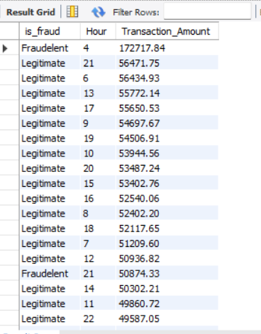

2. Fraud by Transaction Type
— Compared fraud and normal transaction amounts across payment modes such as ATM, POS, QR, and Online.
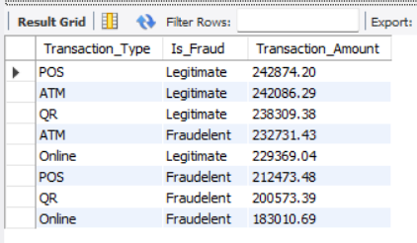

3. Merchant Category Analysis
— Analyzed which merchant categories show higher fraudulent vs legitimate transaction activity.
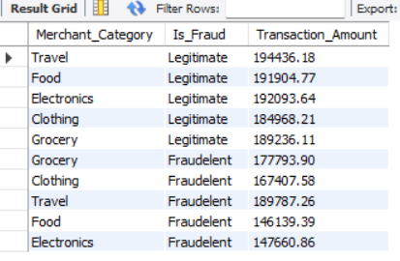

4. Country-wise Fraud Comparison
— Evaluated total fraud and valid transaction amounts across different countries.
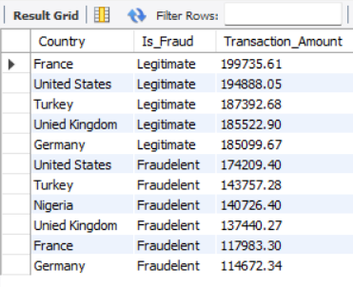

5. User Transaction Activity
— Examined users with the highest number of transactions to detect unusual activity.
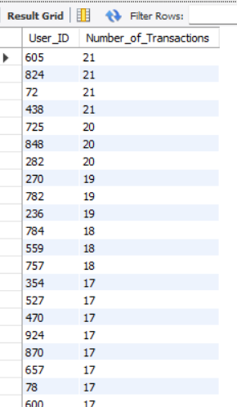

6. Fraud vs Legitimate Amount
— Compared the total monetary value of fraudulent and legitimate transactions overall.
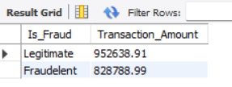

Dashboard in Power Bi

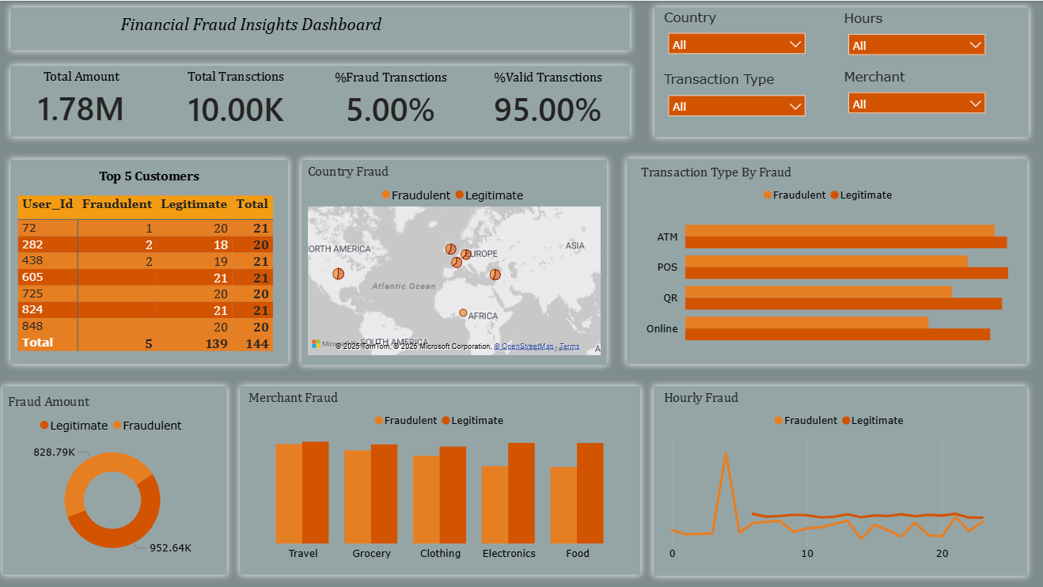

Business Recommendations
- Strengthen High-Risk Countries – Add tighter fraud checks and verification.
- Secure Vulnerable Transaction Types – Use extra authentication for risky modes.
- Monitor Fraud-Heavy Merchant Categories – Track merchants with high fraud ratios.
- Increase Monitoring During Peak Fraud Hours – Apply time-based fraud rules.
- Flag Suspicious Users – Investigate users with abnormal transaction behavior.

